# DAD 220 Module Three Major Activity Database Documentation Template

Ryan Hatch  
SNHU  
5/18/23

## Overview

Complete these steps as you work through the directions for this activity. Replace the bracketed text with your screenshots and brief explanations of the work they show. Each screenshot and its explanation should be sized to approximately one quarter of the page, with the description written below the screenshot. Follow these rules for each of the prompts and questions below. Review the example document for help.

## Create a Database

1. In your integrated development environment (IDE), **create a database schema** called QuantigrationRMA. List out the database name. Provide the SQL commands you ran to successfully complete this in your answer, then connect to it:

*1 Created a database and added 4 rows in the tables.*  
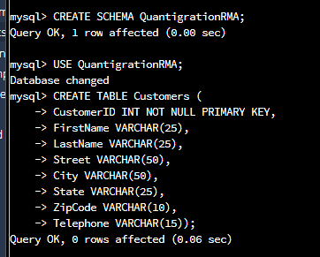 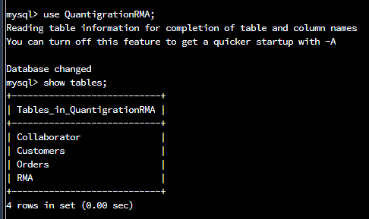

1. Using the entity relationship diagram (ERD) as a reference, **create** the following **tables with the appropriate attributes and keys**:
   1. A table named **customers** in the QuantigrationRMA database as defined on the project ERD. Provide the SQL commands you ran against MySQL to complete this successfully in your answer:

2 Created a table named customers within the created database.

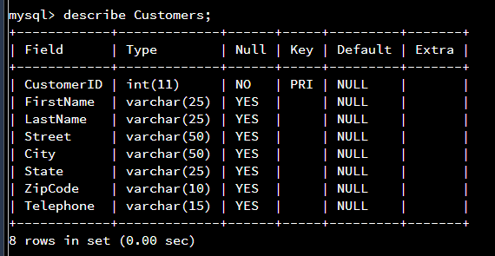

* 1. A table named **orders** in the QuantigrationRMA database as defined on the project ERD. Provide the SQL commands you ran against MySQL to complete this successfully in your answer:

3 Created the orders table.

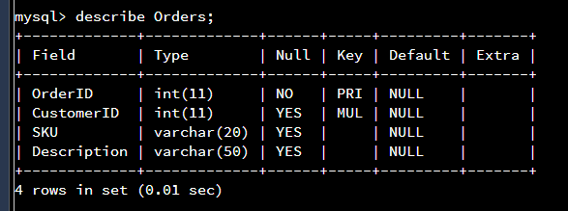

* 1. A table named **rma** in the QuantigrationRMA database as defined on the project ERD. Provide the SQL commands you ran against MySQL to complete this successfully in your answer:

4 Created the RMA table.

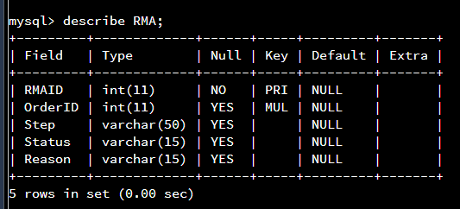

1. Manually **add 10 records** into the **Customers table**. The data can be made up for now, as you you’ll populate all three tables later from the provided CSV files.

5 Created the foundation to my new database it was time to add some test clients.

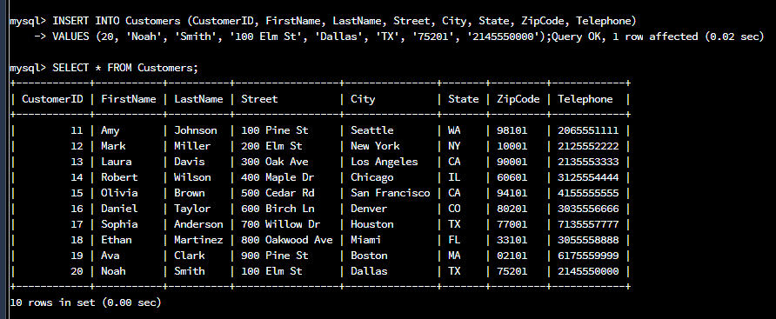

1. Create a view from the **existing Customers table** by using the SQL command provided belowto say "Collaborators." The view should show all instances of "Customer" renamed as "Collaborator."

6 Next it was time to create a view from the customers table and name that Collaborators

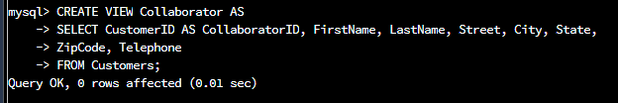

7 And then to describe the collaborator view and test its limit to 5.

